CALL FOR ABSTRACTS FOR

The tenth student philology conference
„Како си ми?“
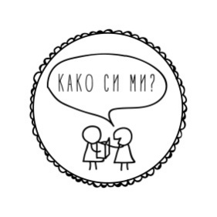

WHEN: the 25th of October 2024

WHERE: In-person, on the faculty campus, with an option for those who cannot travel from abroad to present on the online platform ZOOM. They can record their presentation and send it to the official address of ,,Kako si mi?”

FOR: First and second cycle students at any faculty and university in the Republic of North Macedonia and abroad, as well as for already graduated/master students in the current 2023/2024 academic year, foreign students.

FORMAT: Individual or group presentation with a time limit of 10 minutes.

THEMES: From philology, linguistics, literature, culture, methodology, philosophy, translation and interpretation; as well as comparative, intermediate and interdisciplinary topics.
LANGUAGE
IN WORK: Macedonian and English language

APPLICATION
DEADLINE: the 31st of August 2024, at 10 am

APPLICATION
METHOD: Send the personal data of all participants: name, surname, cycle and year of studies, department, faculty, university, contact email address; topic of presentation, language of presentation and abstract (from 150 to 200 words) at kakosimi.flf@gmail.com in an attached document of the type "Microsoft Word Document (.docx)"

NOTICE OF
ACCEPTED
APSTRACTS: the 5th of September 2024

DEADLINE FOR
SENDING
TEXTS: the 1st of December 2024

CONTACT: kakosimi.flf@gmail.com
facebook.com/kakosimi.flf
kakosimi.wordpress.com
https://www.instagram.com/kakosimi.flf2024/

IMPORTANT: All the costs for travel and accommodation falls on the candidates. An exception can be made regarding accommodation in Skopje, but because of the limited number of free places, you have to inform us in your application. Each case will be decided individually.

„Како си ми?“ is a philology conference organised by students at the Philology Faculty “Blaze Koneski” in Skopje.
The idea of this conference is to stimulate students' interest in research work, public presentation and discussion of topics that interest them during their studies. With this event students are given the opportunity to talk about their academic interests in front of colleagues, professors and interested philology fans. The initiative that was born as an idea in February 2015, has grown into a traditional event in which students, not only from the Faculty of Philology, but also from other faculties in the country and abroad participate. After the presentations, interesting discussions are always developed on current topics from all fields of philology.
The organizing committee of the conference works voluntarily and tries to organize accompanying activities, lectures, workshops and informal gatherings.

